Q.1 Write a procedure to display factorial of a number

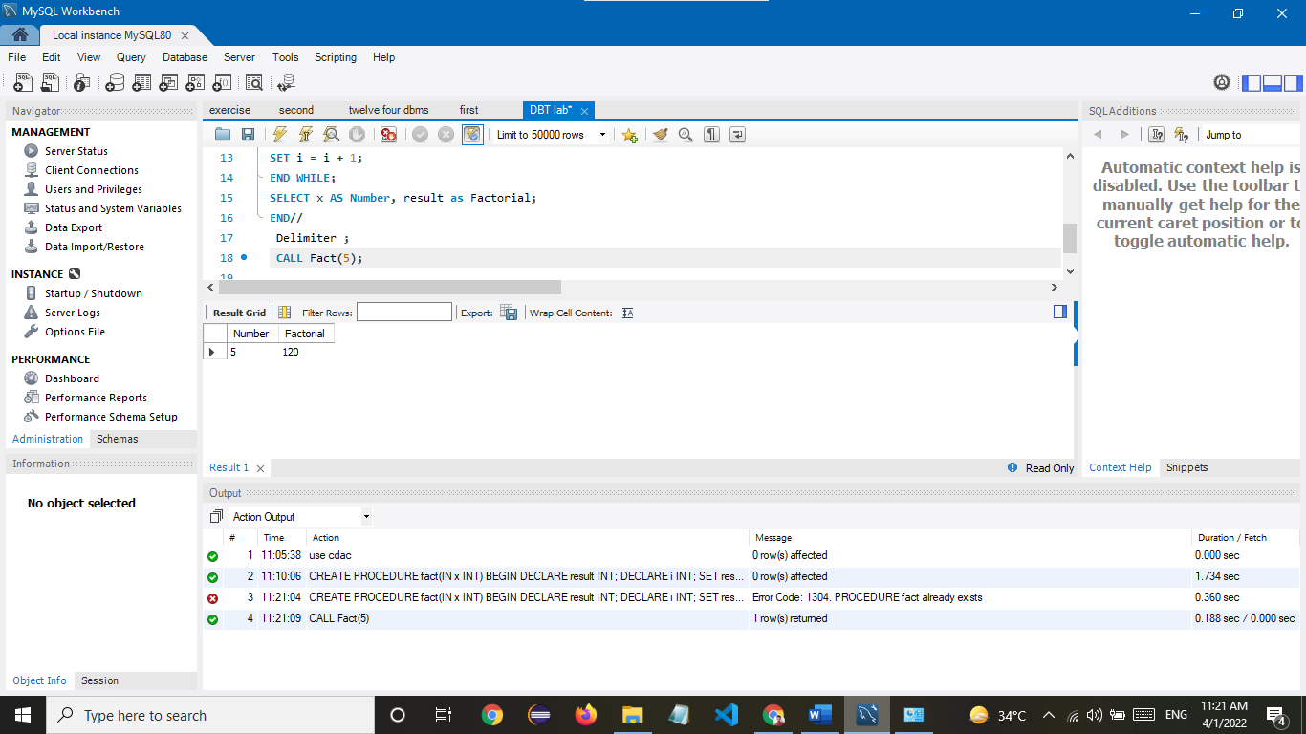

Q.2 Write a query to display second highest salary